Year 12 Chemistry Topic Test # 3 (Organic) - 2013

Name: __________________________________ Mark = _____ / 42

Part One: Multiple Choice Section 10 marks
______________________________________________________________________________

Answer by placing a cross through, or a circle around, the letter of the most correct answer.

1. The structure below represents a polymer commonly used to make gutters and records.

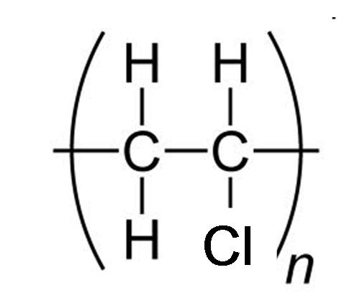

The monomer from which this polymer is made could be:

A. CH₃CH₂C
B. CCH=CH₂
C. CCH=CHC
D. CCH=CHCH=CHC

2. The formula of 2,2-dimethylpropane may be written as:

A. (CH₃)₂CHCH₂CH₃
B. CH₃CH(CH₃)₂
C. C(CH₃)₄
D. (CH₃)₂CHCH₂CH(CH₃)₂

3. One mole of an alkane requires 8 moles of oxygen for complete combustion.
The molecular formula of the alkane is, therefore:

A. C₃H₈
B. C₄H₁₀
C. C₅H₁₂
D. C₆H₁₄

4. Which one of the following compounds would you expect to have the highest boiling point?

A. CH₃CH₂CH₂CHO
B. CH₃CH₂COCH₃
C. CH₃CH₂CH₂CH₂CH₃
D. CH₃CH₂CH₂CH₂OH

5. Which of the following could be used as a soap?

A. propan-1,2,3-triol
B. CH₃CH₂CH₂CH₂CH₂CH₂CH₂CH₂CH₂CH₂CH₂CH₂CH₂CH₂CH₂CH₂CH₂COOH
C. CH₃COO–Na⁺
D. CH₃CH₂CH₂CH₂CH₂CH₂CH₂CH₂CH₂CH₂CH₂CH₂CH₂CH₂CH₂CH₂CH₂COO–K⁺

6. Which of the following molecules will exhibit hydrogen bonding?

I. propanone
II propanal
III propan-2-ol
IV 1-propyl propanoate
V propanamine

A. all of them
B. II, III and V only
C. III and V only
D. II and III

7. Much of the household cleaning that was once performed using soap is now performed using synthetic detergents. A major advantage of synthetic detergents over soap is that
they:

A. have a lower resistance to bacterial decomposition.
B. are non-polar and dissolve more readily in grease.
C. form soluble compounds with common metal ions such as Ca²⁺.
D. are more readily synthesized from common fats and oils.

8. An acidified solution of potassium dichromate would be least likely to react with:

A. CH₃(CH₂)₄CH₂OH
B. CH₃(CH₂)₃CH(OH)CH₃
C. CH₃C(C₂H₅)₂OH
D. CH₃CH₂CH(C₂H₅)CH₂OH

9. Which of the following pairs of compounds are most likely to react to form a polyester?

A. CH₃CHOHCHOHCH₃ and CH₃CHO
B. CH₃COCH₃ and HOOCCH₂COOH
C. HOOCCH₂CH₂COOH and HOCH₂CH₂OH
D. CH₃CH₂OH and CH₃COOH

10. Which of the following can exhibit cis-trans isomerism?

I. CH₂CCH₂C
II. CHI=CHBr
III. CH₂=CC₂
IV. CH₃CH=CHCH₃

A. I, II, and III
B. II, III, and IV
C. II and IV
D. I, II, and IV

End of Part One
Part Two: Short Answer Section 32 marks
______________________________________________________________________________

11. Name and draw full structural formula to represent the following substances:

 | Description | Full structural formula
(a) | a cyclic compound with molecular formula C₄H₆ | Name: ________________________________
(b) | a compound with molecular formula C₄H₈O that can  be oxidised to form  butanoic acid | Name: ________________________________
(c) | a molecule that reacts rapidly with bromine to form 1,2,3,4-tetrabromobutane | Name not required.
(d) | a cyclic tertiary alcohol  with 4 carbon atoms | Name: ________________________________
(e) | the product of oxidising cyclopentanol with acidified potassium permanganate solution | Name: ________________________________
(f) | an organic product that  can be formed when propene undergoes a reaction with bromine | Name: ________________________________

(11 marks)
12. A sweet smelling liquid A (C₆H₁₂O₂) can be hydrolysed by hydrochloric acid to form
B and C. B can be converted into C by reaction with an excess of acidified aqueous
potassium dichromate. Draw structural formulae for A, B and C and name them.

A | Name: __________________________________________
B | Name: __________________________________________
C | Name: __________________________________________

(6 marks)

13. Consider the two alcohols, propan-1-ol and octan-1-ol. Two common solvents are water
and hexane. Predict and account for the relative solubilities of each of these alcohols in
the two solvents.

(a) Solubility in water

_____________________ is more soluble than _____________________

Explanation: ______________________________________________________________

________________________________________________________________________

________________________________________________________________________

________________________________________________________________________
(3 marks)

(b) Solubility in hexane

_____________________ is more soluble than _____________________

Explanation: ______________________________________________________________

________________________________________________________________________

________________________________________________________________________

________________________________________________________________________
(3 marks)
14. Two amino acids are shown below.

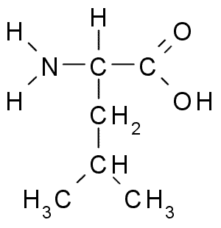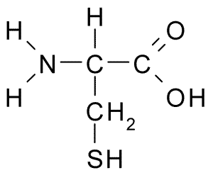
leucine (leu) cysteine (cys)

(a) Assuming that leucine and cysteine are able to form a polymer with alternating
monomer units (i.e. leu-cys-leu-cys), carefully draw ONE repeating unit of the polymer chain.

(1 mark)

(b) During digestion, proteins are broken down into amino acids. Different parts of the
digestive system have different pH’s. For example, the human stomach has a pH
of about 3 whilst the intestine has a pH of about 9. Draw the structure of cysteine
that you would expect in the stomach and the intestine.

stomach | intestine
(2 marks)

(c) Using leucine as an example, draw a zwitterion.

(1 mark)

15. A common polymer is ‘PTFE’, a section of which is shown below.
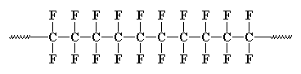
(a) Draw the monomer from which it is made.

(1 mark)

(b) What type of polymersiation is this? _____________________________________
(1 mark)

16. An abbreviated structural formula of 5-hydroxypentanoic acid is HO(CH₂)₄COOH.
In the box beneath, draw its full structural formula.

(1 mark)

5-hydroxypentanoic acid has a molar mass of approximately 118 g mol^{–1}.

When a few drops of concentrated sulfuric acid is added to it, a new compound can be
formed, which has a molar mass of approximately 218 g mol^{–1}. Draw a possible structure
of this compound.

(2 marks)

End of Test

